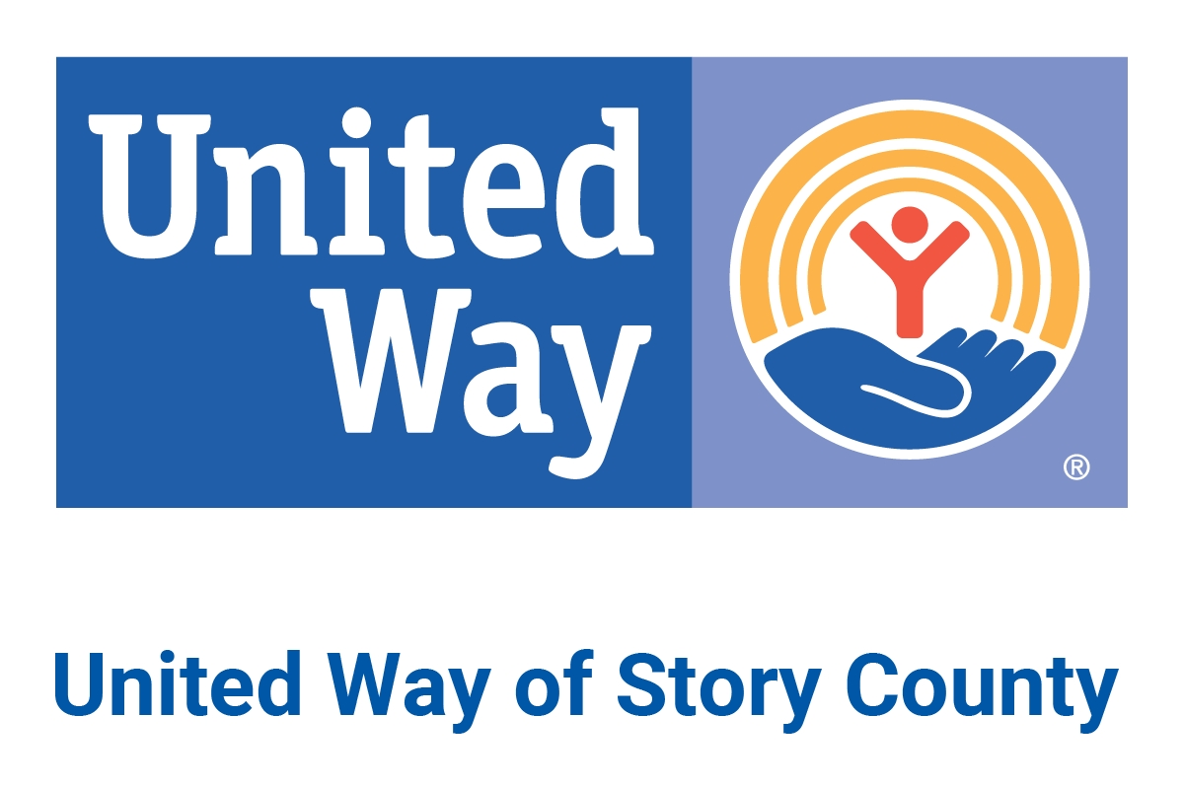

BOARD MEMBER ROLE AND RESPONSIBILITIES

The United Way of Story County (“UWSC”) Board of Directors (“Board”) and its individual members (”Members”) are entrusted by the community with the mission of United Way. They comprise the fiduciary and governing leadership body that leads the organization in advancement of its mission. The Board adopts and follows ethical, legal and financial management policies to ensure that United Way has responsible governance and resources to advance its mission now and into the future. The Board ensures accountability of the President and CEO (“CEO”), and Members hold themselves and each other accountable for achieving organizational goals. Each Member plays a key role in leading UWSC to benefit its community.

1. Scope

UWSC provides the greatest benefit to the community when a strong relationship exists between the Board and CEO. While day-to-day operations are led by the CEO, Members define and support strategic issues and goals, including:

- Setting Direction and Measuring Performance and Results: Members make decisions grounded in community priorities and measure performance on impact, revenue, donors and trust to ensure key organizational results are met.
- Deepening Relevance in Community: Members are visible in the community, and seek to be appropriately engaged in community issues, in a manner aligned with UWSC’s mission.
- Prioritizing: Members’ time, engagement and work are focused mostly on strategic and governance issues, but not to the exclusion of key, sensitive, or timely operational matters.
- Growing Revenue and Donor Base: Members connect UWSC’s efforts and revenue generation campaign to grow financial, social, and relationship resources and advocate on behalf of the organization to achieve community results at scale.
- Leveraging Expertise: Each Member is a talent asset for UWSC. As such, the Board’s composition is reviewed and updated regularly to attract, assess, develop, engage, and retain highly committed leaders.
- Engaging with the United Way Network: Members value the strength of and actively engage with Board s and CEOs from sister United Way organizations and collaborate on common issues.

2. Responsibilities

In a nutshell, Members understand the powerful significance of UWSC’s brand, and they instill trust in UWSC by working with energy and integrity to strengthen and protect the organization’s reputation and long-term sustainability.

Adopted by the UWSC Board 1/27/2022

Mission, Brand, Impact and Business Strategy
- Determine, articulate, and steward the organization's mission, vision, brand, and core values
- Develop new and/or become familiar with existing mission and vision statements, the United Way business model, and goals (long- and short-term) as listed in the strategic plan. Revise and update the strategic plan as needed.
- Set the tone and culture for the organization.
- Monitor and strengthen community impact strategies, programs and services.
- Support UWSC through personal philanthropy and participate in the annual campaign.
- Represent the community in UWSC’s governance.
- Be an ambassador, brand steward and an advocate for UWSC, particularly in the focus areas of health, education and financial stability.

Governance and Fiscal Oversight
- Participate in an orientation session and ongoing training as appropriate.
- Be familiar with and adhere to UWSC’s bylaws and policies, and participate in reviewing and revising them as appropriate.
- Advise on policy development and monitor policy implementation.
- Advise on strategic plan development and updating.
- Hold in confidence Board discussions of personnel, property negotiations and other sensitive and legal matters.
- Govern as Member of the Board, being cognizant of the differentiation in roles and responsibilities of Members and UWSC’s CEO and staff, and in an attitude of reasonable care, honesty and good faith.
- Be committed to diversifying our staff, board, committees and other volunteer leadership positions, and to equity in UWSC’s investment, grant and allocation processes
- Maintain the fiscal integrity of UWSC and ensure compliance with legal, regulatory reporting, and operating requirements.
- Provide oversight of the UWSC endowment and annual campaign.
- Approve and monitor the annual budget.
- Remain informed of UWSC’s financial health.
- Understand that Members are legally responsible for the sound management (fiscal, program, personnel, insurance and property) of UWSC and its compliance with governmental regulations.

CEO Performance and Accountability
- Hire and dismiss the CEO.
- Support the CEO and serve as their partner and trusted advisor.
- At least annually, evaluate the CEO’s performance relative to attaining mission, accomplishing strategic goals, stewarding financial, human capital, and physical resources, meeting performance metrics, maintaining and building organizational culture, and achieving key results.
- Review and approve the CEO’s compensation.
- Ensure a CEO succession plan is in place, while anticipating planned and unplanned departures.

Meetings
- Attend and actively participate in Board meetings, the annual meeting, strategic planning sessions and other relevant governance and committee meetings.
- Review docket materials before attending Board and other organization meetings.
- Engage with and serve on committee(s).

Resource Development
- Advise and set annual and multi-year fundraising goals and supporting metrics and strategies.
- As appropriate, engage with donors and prospects on behalf of UWSC, and solicit gifts in close coordination with UWSC’s organized fundraising efforts.
- Assist with recruitment of campaign volunteers and leaders, and serve on committees/cabinets as appropriate.

Governance
- Ensure the Board’s own continuity of leadership.
- Establish and assess Board performance as a whole and for Members.
- Establish succession plans for Members.
- Working with the Board’s nominating committee and CEO, assist with recruiting new Members.
- Serve on committees and/or task forces, including serving as chair of such bodies, and take on special assignments as appropriate.
- Ensure that a lean and effective committee structure is in place.
- Commit to a diverse Board and staff that reflect the community.
- Individually model best leadership practices and serve as a representative and ambassador of UWSC.

Events and Community Involvement
- Attend and support UWSC annual campaign, endowment and other events.
- Act as liaison to at least one UWSC partner agency.
- Find opportunities to enhance and expand vendor and community partnerships.
- Encourage others to volunteer and engage with UWSC

3. Commitment

Members are elected by the Board.

Members serve a three (3) year term of service, which can be renewed for a second consecutive term. After a period of service on the Board, an individual could become eligible to serve again on the Board again after a one (1) year hiatus.

Board members serve as unpaid volunteers.

UWSC is committed to equal opportunity and recognizes that diverse views, skills, individuals, and lived experiences enable the Board to function most effectively. All nominees for the Board will receive consideration without regard to race, color, age, religion, sex, sexual orientation, gender identity, genetic information, national origin, marital status, disability, or protected Veteran status.

