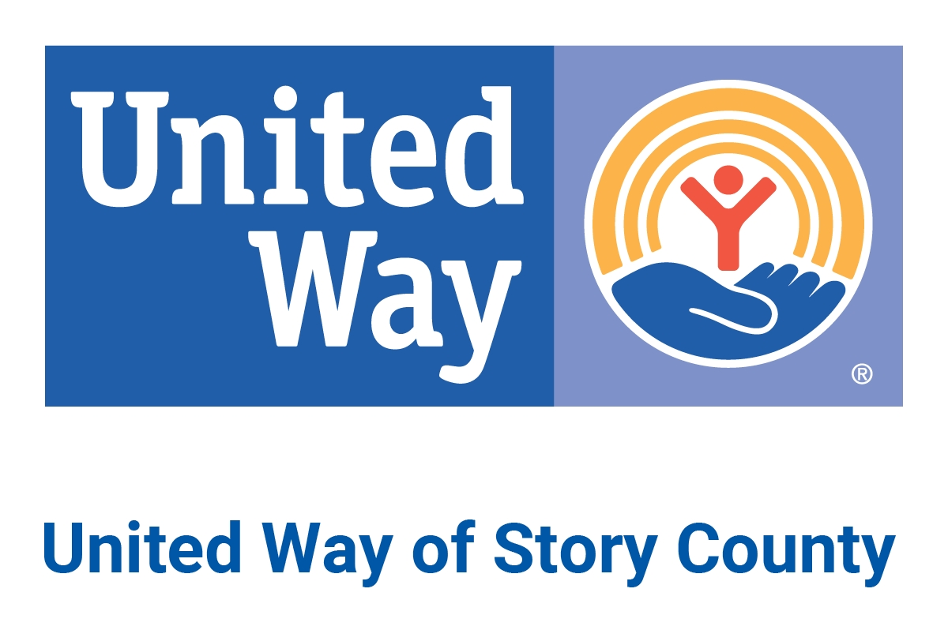

Board of Directors
United Way of Story County

Grant Policy

United Way of Story County (UWSC) grants shall be used to support unanticipated, emerging or other distinct under-funded needs. Qualifying agencies may apply for grants July 1-June 30.

Any UWSC partner agency or non-partner human service agency that provides services in Story County is eligible to apply for UWSC grants when funding for grants is available.

Proposals should be submitted on the attached form. Please respond to all questions. Incomplete proposals will not be accepted. The UWSC Allocations Committee will review proposals and make a recommendation to the UWSC Board of Directors which will make the final decisions on programs and initiatives to be funded.

Proposals should be e-mailed to unitedway@uwstory.org. Call 515-268-5142 with any questions.

Grants shall be made for programs that further the mission of UWSC. Priority will be given to those programs that reach underserved populations and/or are focused on UWSC’s 2025 Community Impact Goals (Appendix B). The 2025 Community Impact Goals include the following areas:

- Health: healthy food access/nutrition programs, mental health awareness programming, mental health services
- Education: a focus on reaching underserved learners through parenting programs, high-quality early childhood education, summer enrichment programs, and reading programs. Community-based education programs also will be considered.
- Financial Stability: emergency food programs, emergency rent & utility programs, programs assisting adults with employment /further education through childcare sliding fee scales or transitional living programs. Other programs that assist families in improving their financial situation will be considered if the program has a method for assessing such improvement.

Grants shall not be made to programs that include inherently religious activities such as worship, prayer, proselytizing or instruction. Those activities must be separated from the UWSC-funded program by time, location or both.
Grant funding may come from:
- previous years income restricted for grants by the UWSC Board of Directors during the annual budget development process
- campaign donations designated by donors to specific service areas during the UWSC annual fundraising campaign
- campaign donations designated by donors to UWSC through other United Way campaigns
- income from special UWSC events or initiatives
- income from the UWSC Endowment
- grants from foundations or corporations
- other sources approved by the UWSC Board of Directors

Agencies applying for grants must submit electronic requests to the UWSC President and CEO (P/CEO) (unitedway@uwstory.org) on the most recent grant application form. After reviewing the applications, the P/CEO shall present the applications to the Allocations Committee for review and funding recommendations. The Allocations Committee generally meets on the first Thursday of each month. Grant applications that have been received by the Monday prior to emailing the agenda packet (typically the Friday prior to the meeting), unless additional information is needed.

Committee recommendations, including approvals and denials, shall be presented to the UWSC Executive Committee and to the UWSC Board of Directors for final funding decisions. UWSC shall notify agencies in writing regarding the status of their proposals.

After final funding decisions have been made, UWSC shall send written agreements to the agencies that submitted approved proposals. After UWSC has received signed written agreements from those agencies, it shall send grant payments to the agencies, unless restrictions have been made on how funds will be paid out. Reports on the status of the programs and use of UWSC funds shall be required of the agencies six months after the initial grant dates, or earlier if applicable.

APPLICATION FOR GRANT

United Way of Story County (UWSC) grants shall be used to support projects/programs that help to fulfill our vision and mission. Priority will be given to those projects/programs that meet one or more of UWSC priority areas in health, education or financial stability.

In general, special grants shall not fund purchase of land or buildings (real property).

Section I – General Information

Agency Date
Submitted By
Name Title
Email Address Phone
Mailing Address (Street, City, State, Zip)
Name of Program
Amount Requested $
Decision on Request Needed By

Section II – Basic Program Information
- Describe program to be funded, including name, description and need being addressed:

- Describe how the need for the project was determined. If applicable, please discuss how this project reaches underserved populations and/or fits into one or more of the UWSC Community Impact 2025 Goal areas:

- List goals and outcomes for the program
  - State the big-picture desired outcome(s). What would you consider “success”?

  - Identify outcomes you will track for UWSC. You must identify at least one but are encouraged to identify multiple:

Health Performance Measures:
# of individuals who participated in health food access/nutrition programs
# of individuals who participated in mental health awareness programming (including domestic abuse, sexual abuse, substance abuse)
# of individuals provided with mental health services (this includes a range of therapeutic services)
# of surveyed individuals AND # of surveyed individuals who reported improved quality of life
Education Performance Measures:
# of children from underserved populations who were enrolled in high-quality early childhood education programs
# of youth from underserved populations who were provided with access to summer enrichment programs
# of families surveyed AND # of surveyed families who reported an increase in their parenting knowledge or skills
# of children who participated in early childhood and out-of-school programming who improved or maintained their reading level. Please specify which literacy assessment tool you use:
# of participants surveyed AND # of surveyed participants in community-based education programs who reported having a better understanding than before

Financial Stability Performance Measures:
# of individuals served through emergency food programs (pantries, shelter food programs, other)
# of households who received financial assistance (rent and/or utilities) to help with housing cost burdens and prevent homelessness
# of adults served (through childcare sliding fee scales and transitional living programs) who were able to remain in school or at their job during the program duration. Please specify the duration assessed:
# of surveyed individuals AND # of surveyed individuals who reported a general improvement in their financial situation due to your program.

Other Performance Measures:
Other: Please specify

- List any collaborating partners:

- If this request meets a need identified as a top priority in a recent needs assessment, please note the need and how the program addresses that need:

- Note which UWSC grant category(ies) apply:
unanticipated need
emerging need
other distinct under-funded need

Section III – Detailed Program Information
- Population to be served, including:
1. Number of constituents

2. Geographical location of constituents

3. Ages of constituents

4. Income level of constituents

5. Do any constituents have disabilities?

6. Race and/or ethnicity of constituents (targets are acceptable if not yet known)

7. Other pertinent details regarding population to be served

- Eligibility requirements for participation in the program:

- Timeline (attach timeline):
1. Is this a one-time or long-term program?

2. If long-term, what is the plan for sustainability?

- Overall budget for program, including: (attach a program/project budget) include revenue sources, amounts and expenses. Note if revenue sources are committed or pending.

1. Fees for participants, if any (attach sliding fee scale if applicable)

2. Specific use of UWSC grant funds

3. Will any part of the budget qualify for matching funds? If so, please explain.

- How will you publicly acknowledge the UWSC grant throughout the program?

Section IV – Required Attachments (not applicable for partner agencies)
- IRS Determination Letter with applicable Internal Revenue Code (such as 501 (c) 3, 170 (c) (1), etc.)
- Federal Employee Identification Number (EIN)
- Board of Directors’ Roster
- Brief Description of the Organization
- Vision and Mission of the Organization

Please submit this form electronically to the P/CEO at unitedway@uwstory.org. If you are not a UWSC partner agency, please include, in addition to this form, a description of the organization and the services provided in Story County.

Please limit your application to a maximum of five written pages and two supporting attachments. Documents that are specifically requested above do not count in the two attachments.

Please contact the UWSC office at 515-268-5142 or unitedway@uwstory.org for more information.

APPENDIX A:

Guidelines for Funding through the UWSC Grants Program

The purpose of the following guidelines is to assist organizations in determining what programs and services would be considered for funding through the grants program for UWSC. This document is intended to be general guidelines only. If you have questions please contact UWSC. This document will be reviewed annually and updated if necessary.

General:
- Proposals that incorporate matching funds or community resources are encouraged. Such outside contributions are a sign or commitment to the project and multiply the effectiveness of the award.
- Each proposal is reviewed on its own merits, leaving maximum flexibility for Allocation Committee decisions.
- Partial funding may be awarded.
- Publicity on grants is encouraged. Please acknowledge support from UWSC whenever possible. Show how long-term funding for the program (if appropriate) will be secured.

Will not fund:
- Capital expenses will generally not be funded (such as computers or other technology hardware) unless you are able to demonstrate that it is essential to implementation of the program.
- Expense not critical to the implementation of the program will not usually be considered (such as T-shirts for events or prizes).
- Please do not rely on funding annually through the grants program to meet ongoing general program expenses (such as staff salaries).
- Endowments.

APPENDIX B:
2025 Community Impact Goals

