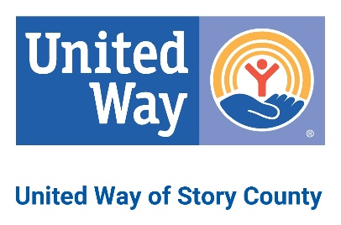

Board of Directors
United Way of Story County

Grant Policy

United Way of Story County (UWSC) grants shall be used to support unanticipated, emerging or other distinct under-funded needs. Qualifying agencies may apply for grants July 1-June 30.

Any UWSC partner agency or non-partner human service agency that provides services in Story County is eligible to apply for UWSC grants when funding for grants is available.

Proposals should be submitted on the provided grant form. Please respond to all questions. Incomplete proposals will not be accepted. The UWSC Allocations Committee will review proposals and make a recommendation to the UWSC Board of Directors which will make the final decisions on programs and initiatives to be funded.

Proposals should be e-mailed to unitedway@uwstory.org. Call 515-268-5142 with any questions.

Grants shall be made for programs that further the mission of UWSC. Priority will be given to those programs that reach underserved populations and/or are focused on UWSC’s 2025 Community Impact Goals (Appendix B). The 2025 Community Impact Goals include the following areas:

- Health: healthy food access/nutrition programs, mental health awareness programming, mental health services
- Education: a focus on reaching underserved learners through parenting programs, high-quality early childhood education, summer enrichment programs, and reading programs. Community-based education programs also will be considered.
- Financial Stability: emergency food programs, emergency rent & utility programs, programs assisting adults with employment /further education through childcare sliding fee scales or transitional living programs. Other programs that assist families in improving their financial situation will be considered if the program has a method for assessing such improvement.

Grants shall not be made to programs that include inherently religious activities such as worship, prayer, proselytizing or instruction. Those activities must be separated from the UWSC-funded program by time, location or both.
Grant funding may come from:
- previous years income restricted for grants by the UWSC Board of Directors during the annual budget development process
- campaign donations designated by donors to specific service areas during the UWSC annual fundraising campaign
- campaign donations designated by donors to UWSC through other United Way campaigns
- income from special UWSC events or initiatives
- income from the UWSC Endowment
- grants from foundations or corporations
- other sources approved by the UWSC Board of Directors

Agencies applying for grants must submit electronic requests to the UWSC President and CEO (P/CEO) (unitedway@uwstory.org) on the most recent grant application form. After reviewing the applications, the P/CEO shall present the applications to the Allocations Committee for review and funding recommendations. The Allocations Committee generally meets on the first Thursday of each month. Grant applications that have been received by the Monday prior to emailing the agenda packet (typically the Friday prior to the meeting), unless additional information is needed.

Committee recommendations, including approvals and denials, shall be presented to the UWSC Executive Committee and to the UWSC Board of Directors for final funding decisions. UWSC shall notify agencies in writing regarding the status of their proposals.

After final funding decisions have been made, UWSC shall send written agreements to the agencies that submitted approved proposals. After UWSC has received signed written agreements from those agencies, it shall send grant payments to the agencies, unless restrictions have been made on how funds will be paid out. Reports on the status of the programs and use of UWSC funds shall be required of the agencies six months after the initial grant dates, or earlier if applicable.

