Your logo here
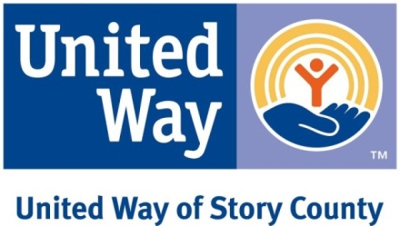

Date

Dear Staff:

Imagine a community where all children have the necessary skills to succeed in school, where all families have their basic needs met, and where all individuals have access to crucial healthcare services like dental care.

This is what we are working to create through our partnership with United Way of Story County. Together we have the power to create a stronger, more vibrant Story County and a better life for us all. Their work touches each of us as concerned citizens and caring educators.

______________ is fortunate to have a strong partnership with United Way of Story County and take pride in connecting our employees with their work in many ways.

Please review the information enclosed to see United Way’s work in more detail or check out one of the campaign activities organized by your colleagues to learn more.

- Event information
- Event information
- Event information

Thank you for helping us LIVE UNITED.

Sincerely,

(Business leader or CEO name here, after approval)

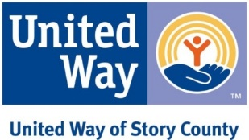
Your logo here

Dear fellow _______ employees,

During the next few weeks, you will be hearing a great deal about our local United Way. United Way of Story County recruits people and organizations from across the community to bring passion, expertise and commitment to get things done. By focusing on the building blocks for a good quality of life — health, education, and financial stability — United Way is strengthening communities and opportunities for all who live there.

Please take time this year to learn more about how United Way is advancing the common good and join me and many other employees who LIVE UNITED. There is a lot you can do. You can give, you can advocate, and you can volunteer. Whatever your decision, we recognize it is a personal one. We value your privacy so no donor names will be shared with supervisors or us as volunteers for United Way of Story County. Our goal is to supply you with an easy way to make an impact and a fun way to learn about the work of United Way of Story County.
Donations of any amount really do make a difference and reach out to many, many services and areas of need right here in Story County. An explanation of United Way’s focus and a pledge form is attached. We encourage you to read about how you can impact our community and make a decision by returning your materials in the internal envelope in the inter-office mail or to a United Way Committee Member by __________.
In addition, over the next few weeks, you will have many opportunities to hear and learn more about the difference United Way makes in our community. We hope to see you at some of these upcoming engagement events!

EVENT INFO
EVENT INFO
EVENT INFO

Please join us in supporting United Way. Thank you for your consideration.

United Way Campaign Committee
Committee Member, department
Committee Member, department
Committee Member, department
Committee Member, department
Committee Member, department
Committee Member, department

